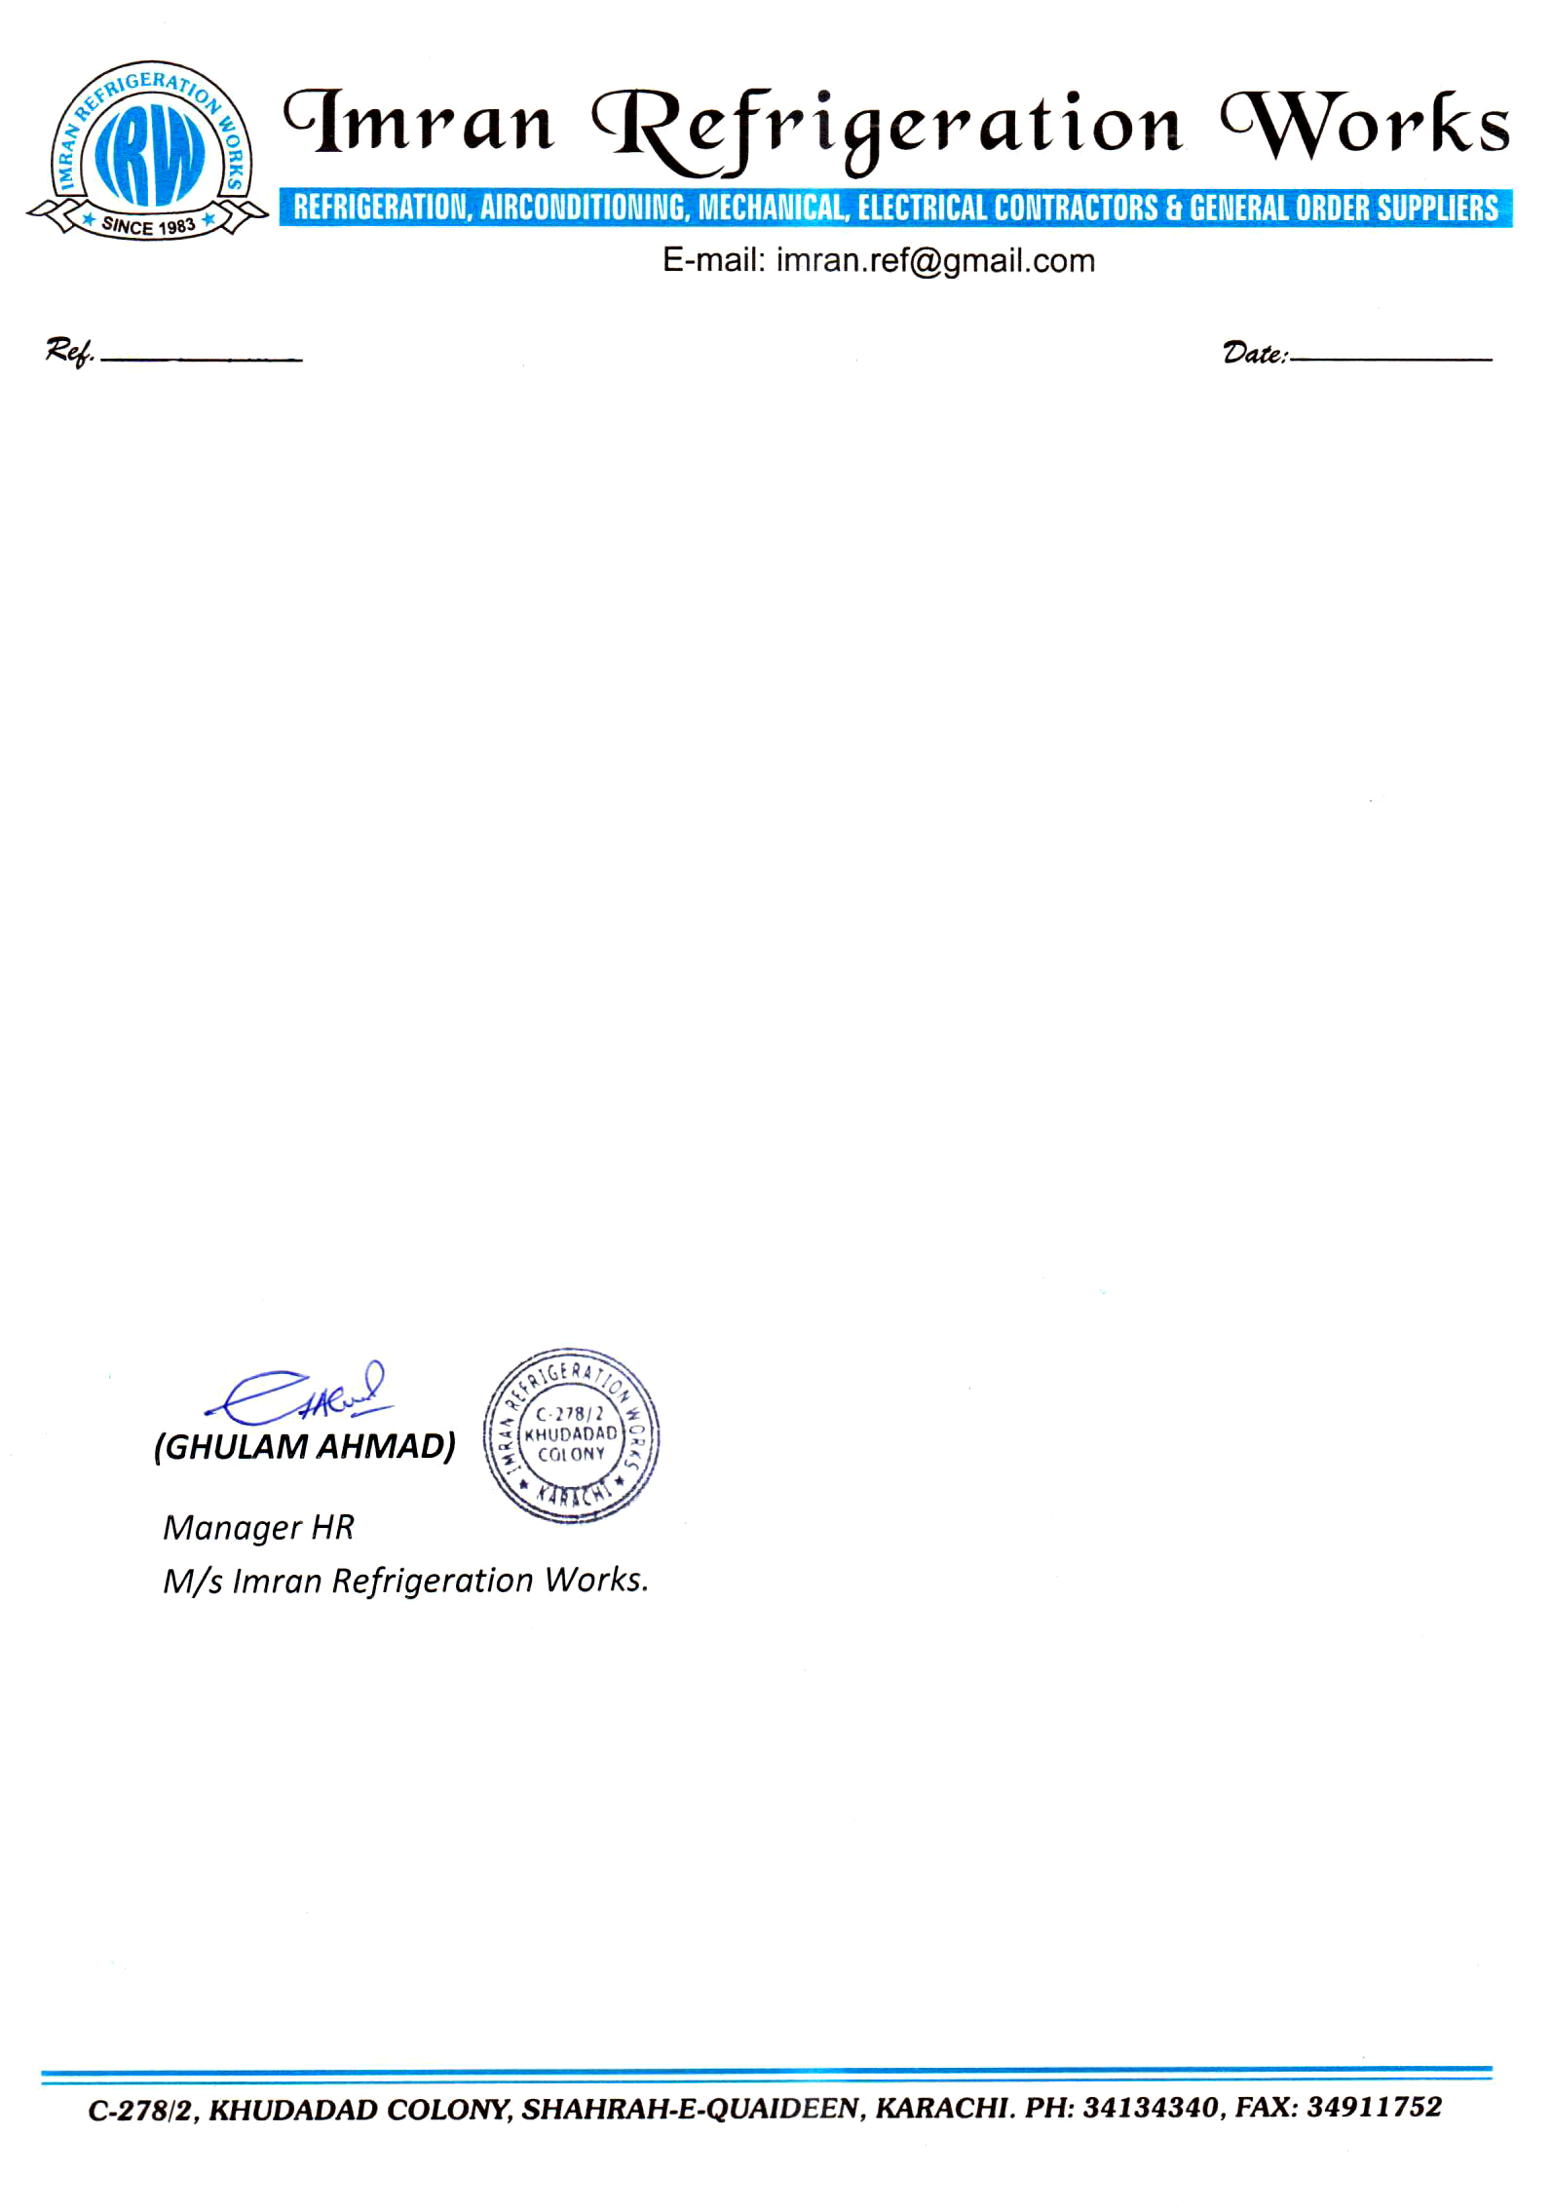

**TO WHOM IT MAY CONCERN**

This is to certify that, Mr. <Name> S/o <fname> CNIC: <CNIC>, has been working in our organization IMRAN REFRIGERATION WORKS Contractor (Civil Aviation Authority) as a <Designation> on Operation & Maintenance of Heating Ventilation & Air-Conditioning System at Multan New International Airport From <From2> to <To2>.

It is further certified that, he has been performing his duties with honesty and diligence.

This certificate is being issued to him upon his own request without any liability what so ever to the company.

We wish him all the success in his future endeavors.